NAME:S.KRISHNA CHAITHANYA 19/06/2026
REG NO:192424287
31.Write a Python program to create a stacked bar plot with error bars.
Aim
To create a stacked bar plot with error bars using Matplotlib. The women's bars are stacked on top of the men's bars using the bottom parameter.
Algorithm
- Import the required libraries (numpy and matplotlib.pyplot).
- Define the mean values and standard deviations for men and women.
- Create positions for the bars using NumPy.
- Plot the men's bars with error bars.
- Plot the women's bars on top of the men's bars using the bottom parameter.
- Add labels, title, and legend.
- Display the stacked bar chart.
Code:
import numpy as np
import matplotlib.pyplot as plt

# Sample data
men_means = (22, 30, 35, 35, 26)
women_means = (25, 32, 30, 35, 29)

men_std = (4, 3, 4, 1, 5)
women_std = (3, 5, 2, 3, 3)

# Position of bars
ind = np.arange(len(men_means))
width = 0.5

# Plot men's bars
p1 = plt.bar(ind, men_means, width,
yerr=men_std,
capsize=5,
label='Men')

# Plot women's bars stacked on men's bars
p2 = plt.bar(ind, women_means, width,
bottom=men_means,
yerr=women_std,
capsize=5,
label='Women')

# Labels and title
plt.ylabel('Scores')
plt.xlabel('Groups')
plt.title('Stacked Bar Plot with Error Bars')
plt.xticks(ind, ('G1', 'G2', 'G3', 'G4', 'G5'))
plt.legend()

plt.show()

Output:
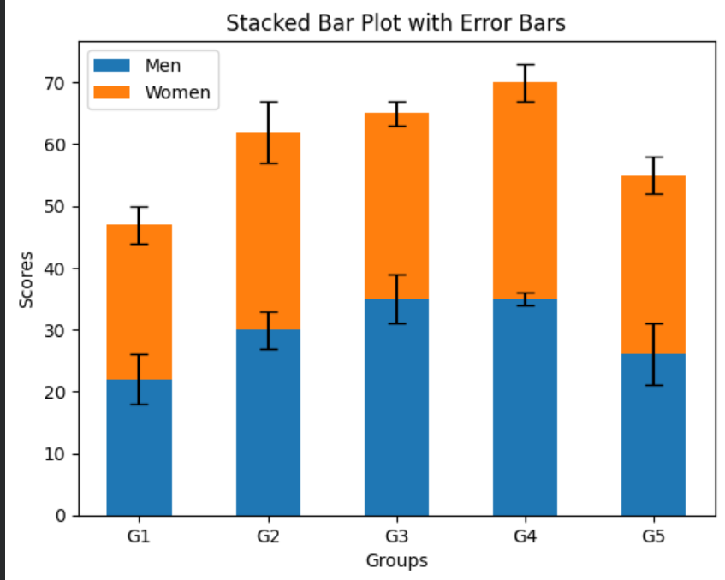
Result:
Thus, a stacked bar plot with error bars was successfully created using Matplotlib, where the women's bars are stacked on top of the men's bars using the bottom parameter.

32.Write a Python program to draw a scatter graph taking a random
distribution in X and Y and plotted against each other.
Aim
To create a scatter graph using random values for X and Y and plot them against each other using Matplotlib.
Algorithm
- Import the required libraries (numpy and matplotlib.pyplot).
- Generate random values for X and Y using NumPy.
- Create a scatter plot using plt.scatter().
- Add title and axis labels.
- Display the graph.
Code:
import numpy as np
import matplotlib.pyplot as plt

# Generate random data
x = np.random.rand(50)
y = np.random.rand(50)

# Create scatter plot
plt.scatter(x, y)

# Labels and title
plt.xlabel('X Values')
plt.ylabel('Y Values')
plt.title('Scatter Plot of Random Distribution')

# Display graph
plt.show()
Output:
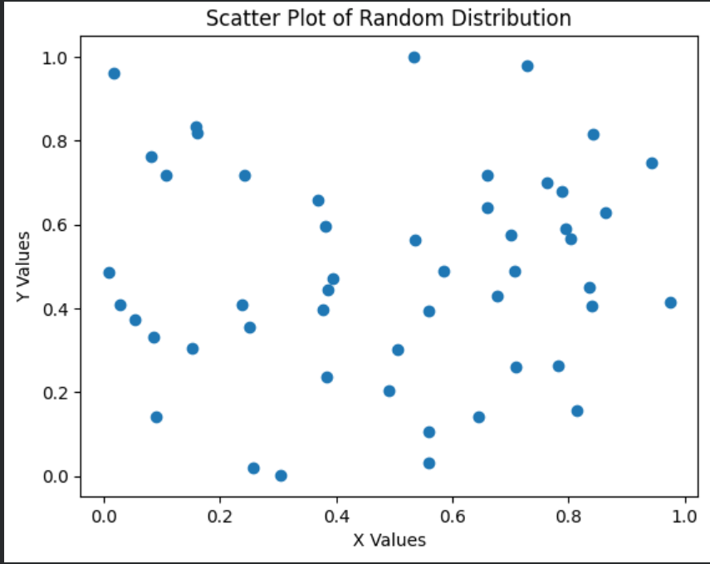
Result:
Thus, a scatter graph was successfully created using randomly generated X and Y values and plotted using Matplotlib's scatter() function.

33.Write a Python program to draw a scatter plot with empty circles taking a
random distribution in X and Y and plotted against each other.
Aim
To draw a scatter plot with empty circles using random distributions of X and Y values and plot them against each other.
Algorithm
- Import the required libraries: matplotlib.pyplot and numpy.
- Generate random values for X and Y using NumPy.
- Create a scatter plot using plt.scatter().
- Set the marker face color to 'none' to create empty circles.
- Add title and axis labels.
- Display the plot.
Code:
import matplotlib.pyplot as plt
import numpy as np

# Generate random data
x = np.random.rand(50)
y = np.random.rand(50)

# Create scatter plot with empty circles
plt.scatter(x, y, s=100, facecolors='none', edgecolors='blue')

# Add title and labels
plt.title("Scatter Plot with Empty Circles")
plt.xlabel("X Values")
plt.ylabel("Y Values")

# Display the plot
plt.show()

Output:
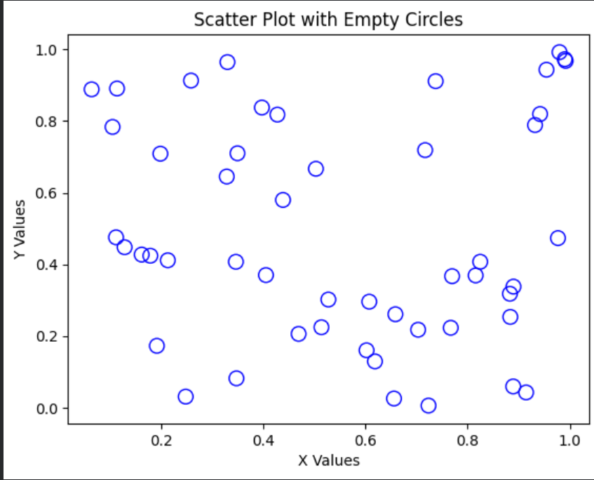
Result
Thus, a Python program to draw a scatter plot with empty circles using random distributions in X and Y was successfully executed.

22/06/2026
34.Write a Python program to draw a scatter plot using random distributions to
generate balls of different sizes.

Aim
To create a scatter plot using random distributions for X and Y coordinates and display points with different ball sizes.
Procedure
- Import the required libraries (matplotlib and numpy).
- Generate random values for X and Y coordinates.
- Generate random values for the sizes of the balls.
- Create a scatter plot using the generated data.
- Display the plot with labels and a title.
Code:
import numpy as np
import matplotlib.pyplot as plt

x = np.random.rand(50)
y = np.random.rand(50)
sizes = np.random.randint(50, 1000, 50)

plt.scatter(x, y, s=sizes, alpha=0.5)
plt.title("Scatter Plot with Different Ball Sizes")
plt.xlabel("X Values")
plt.ylabel("Y Values")
plt.show()

Output:
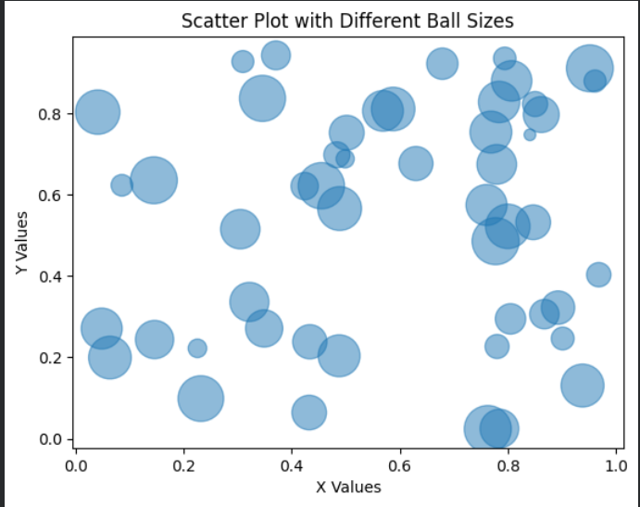
Result:
Thus, a scatter plot using random distributions with balls of different sizes was created and displayed successfully.

35.Write a Python program to draw a scatter plot comparing two subject
marks of Mathematics and Science. Use marks of 10 students.
Aim
To draw a scatter plot comparing the marks of 10 students in Mathematics and Science.
Procedure
- Import the matplotlib.pyplot library.
- Create lists for Mathematics marks, Science marks, and student mark ranges.
- Use the scatter() function to plot the data.
- Add a title and labels for the axes.
- Display the graph using show().

Code:
import matplotlib.pyplot as plt

math_marks = [88, 92, 80, 89, 100, 80, 60, 100, 80, 34]
science_marks = [35, 79, 79, 48, 100, 88, 32, 45, 20, 30]
marks_range = [10, 20, 30, 40, 50, 60, 70, 80, 90, 100]

plt.scatter(math_marks, science_marks)

plt.title("Scatter Plot of Mathematics vs Science Marks")
plt.xlabel("Mathematics Marks")
plt.ylabel("Science Marks")

plt.show()

Output:
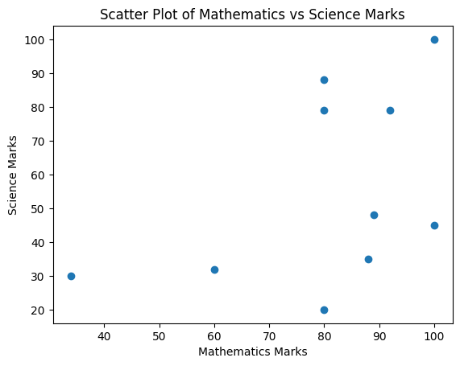
Result
The scatter plot comparing Mathematics and Science marks of 10 students was successfully plotted.

36.Write a Python program to draw a scatter plot for three different groups
comparing weights and heights.
Aim
To draw a scatter plot for three different groups comparing weights and heights.
Procedure
- Import the matplotlib.pyplot library.
- Create separate height and weight data for three groups.
- Use the scatter() function to plot each group.
- Add labels, title, and legend.
- Display the scatter plot.
Code:
import matplotlib.pyplot as plt

height_group1 = [150, 155, 160, 165, 170]
weight_group1 = [50, 55, 60, 65, 70]

height_group2 = [152, 158, 163, 168, 172]
weight_group2 = [52, 57, 62, 67, 72]

height_group3 = [148, 153, 159, 164, 169]
weight_group3 = [48, 53, 58, 63, 68]

plt.scatter(height_group1, weight_group1, label='Group 1')
plt.scatter(height_group2, weight_group2, label='Group 2')
plt.scatter(height_group3, weight_group3, label='Group 3')

plt.title('Height vs Weight Comparison')
plt.xlabel('Height (cm)')
plt.ylabel('Weight (kg)')
plt.legend()

plt.show()

Output:
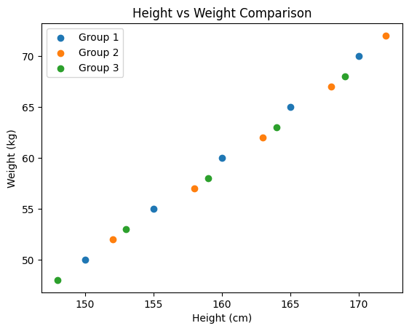

23/06/2026
37.Write a Pandas program to create a dataframe from a dictionary
Aim
To create a Pandas DataFrame from a dictionary and display it.
Procedure
- Import the Pandas library.
- Create a dictionary containing the given data.
- Convert the dictionary into a DataFrame using pd.DataFrame().
- Display the DataFrame using print().
Code:
import pandas as pd

data = {
'X': [78, 85, 96, 80, 86],
'Y': [84, 94, 89, 83, 86],
'Z': [86, 97, 96, 72, 83]
}

df = pd.DataFrame(data)

print(df)

Output:
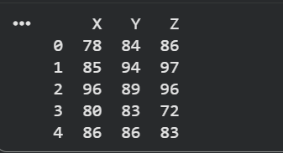
Result
The DataFrame was successfully created from the given dictionary and displayed.

38.Write a Pandas program to create and display a DataFrame from a
specified dictionary data which has the index labels.
Aim
To create and display a Pandas DataFrame from a specified dictionary with custom index labels.
Procedure
- Import the Pandas and NumPy libraries.
- Create a dictionary containing the given data.
- Create a list of index labels.
- Use pd.DataFrame() to create the DataFrame with the specified index labels.
- Display the DataFrame using print().
Code:
import pandas as pd
import numpy as np

exam_data = {
'name': ['Anastasia', 'Dima', 'Katherine', 'James', 'Emily',
'Michael', 'Matthew', 'Laura', 'Kevin', 'Jonas'],
'score': [12.5, 9, 16.5, np.nan, 9, 20, 14.5, np.nan, 8, 19],
'attempts': [1, 3, 2, 3, 2, 3, 1, 1, 2, 1],
'qualify': ['yes', 'no', 'yes', 'no', 'no',
'yes', 'yes', 'no', 'no', 'yes']
}

labels = ['a', 'b', 'c', 'd', 'e', 'f', 'g', 'h', 'i', 'j']

df = pd.DataFrame(exam_data, index=labels)

print(df)
Output:
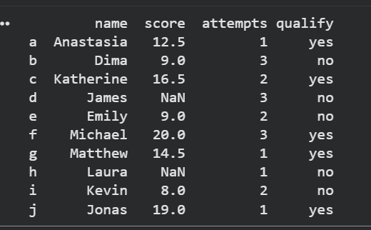
Result
The DataFrame was successfully created from the given dictionary with the specified index labels and displayed.

39.Write a Pandas program to get the first 3 rows of a given DataFrame.
Sample Python dictionary data and list labels:

Aim
To create a Pandas DataFrame from the given dictionary and display the first 3 rows of the DataFrame.
Procedure
- Import the Pandas and NumPy libraries.
- Create a dictionary containing student data.
- Create a list of labels to use as the DataFrame index.
- Convert the dictionary into a DataFrame.
- Use the head(3) function to display the first three rows.
- Print the result.
Code:
import pandas as pd
import numpy as np

# Dictionary data
exam_data = {
'name': ['Anastasia', 'Dima', 'Katherine', 'James', 'Emily',
'Michael', 'Matthew', 'Laura', 'Kevin', 'Jonas'],
'score': [12.5, 9, 16.5, np.nan, 9, 20, 14.5, np.nan, 8, 19],
'attempts': [1, 3, 2, 3, 2, 3, 1, 1, 2, 1],
'qualify': ['yes', 'no', 'yes', 'no', 'no',
'yes', 'yes', 'no', 'no', 'yes']
}

# Index labels
labels = ['a', 'b', 'c', 'd', 'e', 'f', 'g', 'h', 'i', 'j']

# Create DataFrame
df = pd.DataFrame(exam_data, index=labels)

# Display first 3 rows
print(df.head(3))

Output:
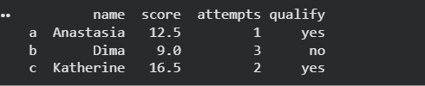
Result
The first three rows of the DataFrame were successfully displayed using the head(3) method.

40. Write a Pandas program to select the &#39;name&#39; and &#39;score&#39; columns
Aim
To create a Pandas DataFrame from the given dictionary and select only the 'name' and 'score' columns.
Procedure
- Import the Pandas and NumPy libraries.
- Create the dictionary containing student information.
- Create the DataFrame using the given labels as index.
- Select the 'name' and 'score' columns using column indexing.
- Display the selected columns.
Code:
import pandas as pd
import numpy as np

# Dictionary data
exam_data = {
'name': ['Anastasia', 'Dima', 'Katherine', 'James', 'Emily',
'Michael', 'Matthew', 'Laura', 'Kevin', 'Jonas'],
'score': [12.5, 9, 16.5, np.nan, 9, 20, 14.5, np.nan, 8, 19],
'attempts': [1, 3, 2, 3, 2, 3, 1, 1, 2, 1],
'qualify': ['yes', 'no', 'yes', 'no', 'no',
'yes', 'yes', 'no', 'no', 'yes']
}

# Labels
labels = ['a', 'b', 'c', 'd', 'e', 'f', 'g', 'h', 'i', 'j']

# Create DataFrame
df = pd.DataFrame(exam_data, index=labels)

# Select 'name' and 'score' columns
result = df[['name', 'score']]

# Display result
print(result)

Output:
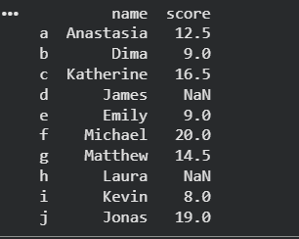
Result
The 'name' and 'score' columns were successfully selected and displayed from the DataFrame.

